We have been busy putting together a whole alphabet of activities, songs, stories and thing to keep you busy over the Summer. We hope you have a fun, safe summer full of excitement and new experiences and we look forward to seeing you in September.

The Young Saints Team

 | Story / message | Activity
A  Arrow prayer | An Arrow Prayer is a simple, short prayer that brings us right into the presence of God. Very often Arrow Prayers are just a couple of words, a sentence or less.  An arrow prayer is distinguished by the lightning speed with which we shoot it up to God. This is necessary because we may not have time to stop because we need to act at the very same split second something is happening. Therefore, arrow prayers typically aren’t carefully worded, long or even completely coherent. In fact, arrow prayers may only be one word long.  Here are two times you can use arrow prayers:  When you need help or guidance: Lord help me. Show me what to do. Tell me what to say. Send someone to help me. Give me courage. I’m afraid. I can’t do this without you.  To say Thanks: Lord, Thank you for the butterflies/ flowers/ rainbow. Thank you for our food. Thank you for the love of my family.. | Make a paper plane.  Write your prayer on the plane and throw it while saying the prayer out loud.
B  Baptism | John the Baptist baptises Jesus  https://www.youtube.com/watch?v=oGMCA_aUY4c  Discuss the story. Jesus didn’t have any sins so he didn’t need to be baptised but he wanted others to see how important it was to be sorry for things we’ve done wrong, repent and ask God to forgive us.  (See also Vow below) | Baptism jigsaw  Stick the picture on to card or stiff paper. Cut it into pieces to make a jigsaw (the number of pieces will depend on the age of your children).
C  Candle | We use candles to symbolise the light that Jesus brought into the world. There are special candles for different times of year or different events in church like baptism, christingle and advent. | You need an adult to help you with this one!  Ask a grown up to help you find and light a small candle. They could help you to put the light in a window to share with others. When it is time to put the candle out watch the smoke rising up as our prayers rise up to God.  If you can’t light a real candle you can visit https://www.churchofengland.org/our-faith/light-candle and light a virtual one!
D  David and Goliath | David and Goliath  https://www.youtube.com/watch?v=7zLAcUZkxHA | David and Goliath colour by numbers picture
E  Eucharist | The Eucharist is where we share bread and wine together to remember the last supper, the meal that Jesus shared with his disciples before he died. It is a very special thing to share for christians. | A special meal.  Could you help to make a special meal for someone?  Next time you go to the supermarket ask the grown up you are with if you can add a few things to your trolley to donate to Foodshare which provides food for people who are in need. It could be a tin of soup or a packet of pasta or tea. You can then put the food in the foodshare collection boxes in the supermarket. If we each did this every time we shop we could provide lots of special meals for people. What a great way to remember the sacrifice that was made for us.
F  Fishing for Men | Matthew 4:18-20  18 And Jesus, walking by the Sea of Galilee, saw two brethren, Simon called Peter and Andrew his brother, casting a net into the sea; for they were fishers.  19 And He said unto them, “Follow Me, and I will make you fishers of men.”  20 And they straightway left their nets and followed Him | Have a go at making this super easy fishing game:  https://www.youtube.com/watch?v=ErbM4I8655g
G  Gospel | The first four books of the New Testament are called the Gospels. In church you will here people reading from them and might even be asked to read from them yourself.  They are the books of Matthew, Mark, Luke and John and they share the message of Jesus. | Be a gospel detective!  Pick a Gospel and find out the following (you can use the internet or an encyclopedia to help)  When was it written?  Who wrote it?  Where did they live?  How did they know about Jesus?  What can you find out about their life?  Now see if you can find a story in the Gospel you have picked that you like. You could practice reading it because when we get back to the church we would love to hear it. PS. If you don’t have access to a bible please let one of the Young Saints Leaders know and we will get one for you.
H  Homeschool | Oh no not more school!  We know it is the summer which should be all about running around, climibing trees and having adventures, but just in case it rains there are some great online resources you can check out! | https://www.biblesociety.org.uk/explore-the-bible/homeschool-resources/  https://www.messychurch.org.uk/resources/messy-church-home-ideas
I  I Can! | ‘I can do all this through him who gives me strength’  Philippians 4:13  Basically - you can do anything because God will give you strength - you just need to ask. | Get yourself a goal.  Kind of like a new years resolution only better! Think about something you want to practice over the summer and then do a little bit every day until you have absolutely cracked it. It could be tying your shoes, learning to swim or learning to cook. It could be absolutely anything! MIne is going to be learning to ride a bike so if you see me wobbling around Maidenhead say hello!
J  Jonah and the Whale | Time for a story:  https://www.youtube.com/watch?v=KOwoJsuGqd8 | Have a look at this Lego version of the story Jonah and the Whale.  Can you make your own Lego Bible story? Snap a pic and share with us.
K  King | We call Jesus King and we talk in church about the kingdom of God but what does that mean?  Luke 17:20-21 The Coming of the Kingdom of God  20 Once, on being asked by the Pharisees when the kingdom of God would come, Jesus replied, “The coming of the kingdom of God is not something that can be observed, 21 nor will people say, ‘Here it is,’ or ‘There it is,’ because the kingdom of God is in your midst.”[a] | How will we recognise the KIngdom of God? What do you think Jesus is trying to say? How could you help make the KIngdom of God on earth  Try and come up with some words to fill this in:  Kindness  i  neighbour  g  d  o  m
L  Light | Jesus said: “I am the light of the world. Whoever follows me will never walk in darkness, but will have the light of life. “ John 8:12  Shine Jesus Shine song  https://www.youtube.com/watch?v=uaTwx0ehbvM  Shine Jesus Shine  Graham Kendrick  Lord, the light of your love is shining  In the midst of the darkness, shining  Jesus, Light of the world, shine upon us  Set us free by the truth you now bring us  Shine on me, shine on me  Shine, Jesus, shine  Fill this land with the Father's glory  Blaze, Spirit, blaze  Set our hearts on fire  Flow, river, flow  Flood the nations with grace and mercy  Send forth your word  Lord, and let there be light  Lord, I come to your awesome presence  From the shadows into your radiance  By the blood I may enter your brightness  Search me, try me, consume all my darkness  Shine on me, shine on me  Shine, Jesus, shine  Fill this land with the Father's glory  Blaze, Spirit, blaze  Set our hearts on fire  Flow, river, flow  Flood the nations with grace and mercy  Send forth your word  Lord, and let…  As we gaze on your kingly brightness  So our faces display your likeness  Ever changing from glory to glory  Mirrored here may our lives tell your story  Shine on me, shine on me  Shine, Jesus, shine  Fill this land with the Father's glory  Blaze, Spirit, blaze  Set our hearts on fire  Flow, river, flow  Flood the nations with grace and mercy  Send forth your word  Lord, and let there be  Send forth your  Send forth your word  Lord, and let there  Send forth your word  Send forth your word  Lord, and let there be light  Source: Musixmatch | Make a paper candle  Make a tube from a piece of paper. Cut 4x 2 cm cuts in one end to enable the candle to stand up.  Cut out a flame shape and colour it. Stick this to the top of your tube.  Sing the song.  See if you can learn the song.  If you play a musical instrument, ask someone at home or your music teacher to find you the music of this song. You could learn to play it over the summer.
M  Music | We love music! It helps us celebrate our faith and share it with others. Dancing is also encouraged as is loud banding of pots, jiggling of bells and anything else you can make a noise with. | Raise the roof!  (sorry mums and dads!)  Pick out your favourite song, it could be hymn or a song from church but it doesn’t have to be. This is about celebrating our bodies, our voices and all of the gifts we have been given. Play your song and do the silliest dance you can think of. As you do feel the joy in music and remember the gifts we have all been given!
N  Neighbour | 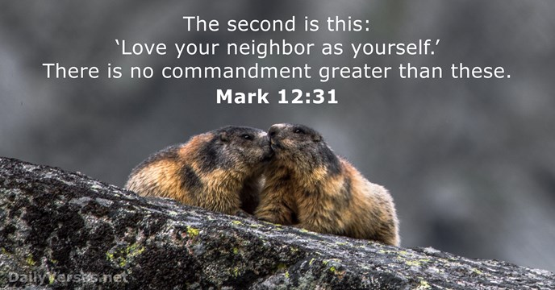 | We have talked before about ways that we can help others but your mission is to be a good neighbour. Think of 5 things you could do to be a good neighbour over the summer. It could be:  Doing a job or chore for someone who needs help  Helping our at home  Picking up litter when you see it  Making friends with someone at school who doesn’t have many
O  Our Father | Our Father in heaven,  hallowed be your name,  your kingdom come,  your will be done,  on earth as in heaven.  Give us today our daily bread.  Forgive us our sins  as we forgive those who sin against us.  Lead us not into temptation  but deliver us from evil.  For the kingdom, the power,  and the glory are yours  now and for ever.  Amen. | Try and say this prayer every day.  See if you can learn it by heart!
P  Prayer | We can’t talk about prayer enough and you can’t talk to God too much. | 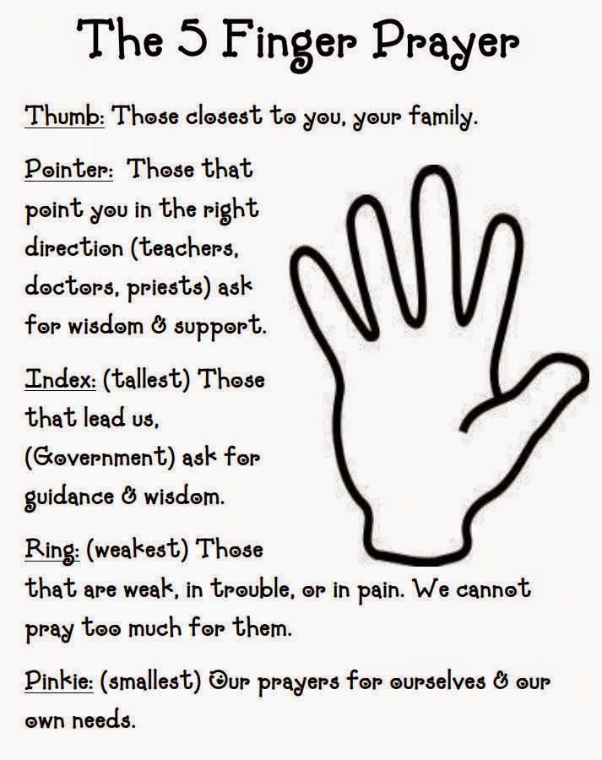
Q  Quiet | When you read the Bible you will often find times that Jesus would take a few minutes, (or even a few days) away from others to have some quiet time to himself, to think and to pray. Being quiet is ok. Sometimes the world is loud with noise and excitement and things that we need to do so sometimes it is a great idea to have a few quiet minutes. | Maybe try this one after M for Music!  Sit in the garden, park or somewhere else outside. Close your eyes and open your ears. What can you hear? Try and distinguish as many different sounds from the hustle and bustle as you can. Can you hear the birds? how many?
R  Rainbow | Genesis 9-12  8 Then God said to Noah and to his sons with him: 9 “I now establish my covenant with you and with your descendants after you 10 and with every living creature that was with you—the birds, the livestock and all the wild animals, all those that came out of the ark with you—every living creature on earth. 11 I establish my covenant with you: Never again will all life be destroyed by the waters of a flood; never again will there be a flood to destroy the earth.”  12 And God said, “This is the sign of the covenant I am making between me and you and every living creature with you, a covenant for all generations to come: 13 I have set my rainbow in the clouds, and it will be the sign of the covenant between me and the earth. 14 Whenever I bring clouds over the earth and the rainbow appears in the clouds, 15 I will remember my covenant between me and you and all living creatures of every kind. Never again will the waters become a flood to destroy all life. 16 Whenever the rainbow appears in the clouds, I will see it and remember the everlasting covenant between God and all living creatures of every kind on the earth.”  17 So God said to Noah, “This is the sign of the covenant I have established between me and all life on the earth.” | There are lots of rainbows around at the moment as signs of hope and thanks for all those taking care of people during the corona virus outbreak.  Here are some other ways to bring a rainbow into your life:  Blow some bubbles and see the way the light makes a rainbow on each one  Make a rainbow fruit salad - pretty and delicious - a great way to celebrate the bounty given to us by God  Make a giant rainbow. In your back garden find lots of different coloured clothes and other items to lay on the clean! dry! ground (ask a grown up first) then take a picture from an upstairs window.
S  Star | Stars are mentioned about 60 times in the Bible.  Probably the most famous time is at the birth of baby Jesus. “Some men who studied the stars came from the east to Jerusalem and asked “Where is the baby born to be the king of the Jews? We saw his star when it came up in the east and we have come to worship him.” Matthew 2 verses 1&2. | Bake star cookies
T  Two by Two | Noah and the Flood  9 This is the account of Noah and his family.  Noah was a righteous man, blameless among the people of his time, and he walked faithfully with God. 10 Noah had three sons: Shem, Ham and Japheth.  11 Now the earth was corrupt in God’s sight and was full of violence. 12 God saw how corrupt the earth had become, for all the people on earth had corrupted their ways. 13 So God said to Noah, “I am going to put an end to all people, for the earth is filled with violence because of them. I am surely going to destroy both them and the earth. 14 So make yourself an ark of cypress[c] wood; make rooms in it and coat it with pitch inside and out. 15 This is how you are to build it: The ark is to be three hundred cubits long, fifty cubits wide and thirty cubits high.[d] 16 Make a roof for it, leaving below the roof an opening one cubit[e] high all around.[f] Put a door in the side of the ark and make lower, middle and upper decks. 17 I am going to bring floodwaters on the earth to destroy all life under the heavens, every creature that has the breath of life in it. Everything on earth will perish. 18 But I will establish my covenant with you, and you will enter the ark—you and your sons and your wife and your sons’ wives with you. 19 You are to bring into the ark two of all living creatures, male and female, to keep them alive with you. 20 Two of every kind of bird, of every kind of animal and of every kind of creature that moves along the ground will come to you to be kept alive. 21 You are to take every kind of food that is to be eaten and store it away as food for you and for them.”  22 Noah did everything just as God commanded him. | https://www.bbc.co.uk/teach/school-radio/nursery-rhymes-the-animals-went-in-two-by-two/zr88bdm  We love this song but can you think of any more animals that need to head on into that ark? See if you can write your own verse!
U  Umbrella |  | We hope the sun will shine but sometimes the rain comes too.  You can stand under someone else's umbrella  and you can be an umbrella too.
V  Vow | A vow is a promise.  During baptism, your parents and godparents promise to pray for you and introduce you to God and Jesus – to help you be a ‘light in the world!.  The baby, child or adult is welcomed into the church.  (See also Baptism above) | Have you been in church when there was a baptism? What can you remember?  (E.g. going to the font and having the sign of the cross made with holy water; godparents making promises; baby wearing special clothes…)  If you have been baptised, talk to your parents about this. See if you can find any photos.
X | Ok so we couldn’t come up with anything for X. | Can you?
Y  You | God and Jesus love all of us – yes, you too!  The Little Children and Jesus  People were bringing little children to Jesus for him to place his hands on them, but the disciples rebuked them. When Jesus saw this, he was indignant. He said to them, “Let the little children come to me, and do not hinder them, for the kingdom of God belongs to such as these. Truly I tell you, anyone who will not receive the kingdom of God like a little child will never enter it.” And he took the children in his arms, placed his hands on them and blessed them.  (Mark 10:13-16)  Here’s a song that reminds us of this.  https://www.youtube.com/watch?v=owx3ao42kwI  Jesus Loves Me  Jesus loves me, this I know  For the Bible tells me so  Little ones to Him belong  They are weak, but He is strong  Yes, Jesus loves me  Yes, Jesus loves me  Yes, Jesus loves me  The Bible tells me so  Jesus loves me, He who died  Heaven's gate to open wide  He will wash away my sin  Let His little child come in  Yes, Jesus loves me  Yes, Jesus loves…  Yes, Jesus loves me  Yes, Jesus loves me  Yes, Jesus loves me  The Bible tells me so  The Bible tells me so  Source: Musixmatch | Make a photo picture  Take a sheet of paper and stick your photo on one side. On the other half, draw a large heart and write inside “Jesus loves me”.  See if you can learn the song.  If you play a musical instrument, ask someone at home or your music teacher to find you the music of this song. You could learn to play it over the summer.
Z  zzzzzzzzzz | We hope you have enjoyed trying out some of these ideas.  We are off to sleep now!  Have a wonderful summer sharing in the love of God.  YS x

